**Applitools: Visual Testing Tool**

**1. What is Visual Testing:**

1. Quality Assurance Activity

2. Verify GUI (layout, color, Shape etc) appears correctly.

3. Important for Companies reputation point of view

**2. Introduction of Applitools:** Applitools is a tool to test UI components effectively.  
Different from Tool like Selenium.   
Reduces Line of Code comparing to traditional Selenium script.

Automated Visual Testing tool because Manual testing is too time consuming.

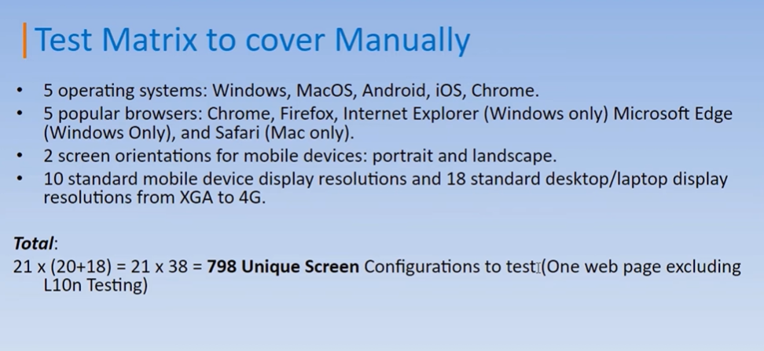

**Why Applitools Eyes?**AI Powered visual testing and monitoring tool.

Support various test tools and languages

1. Selenium, Cypress, Appium etc
2. Java, C#, JS, Python etc

Less code to write

Handles Dynamic content

Can be integrated with many tools

**How Does it work?**

AUT – Application Under Test

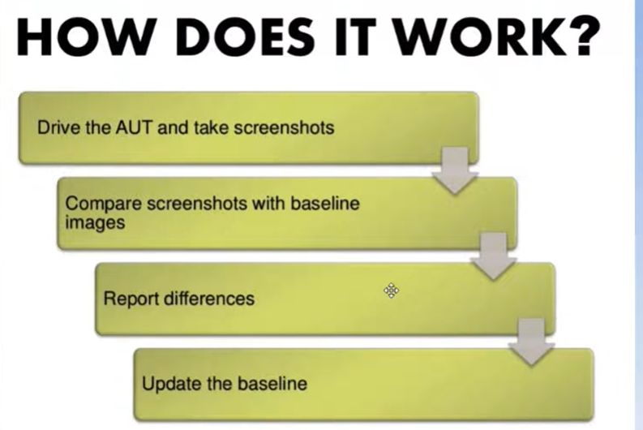

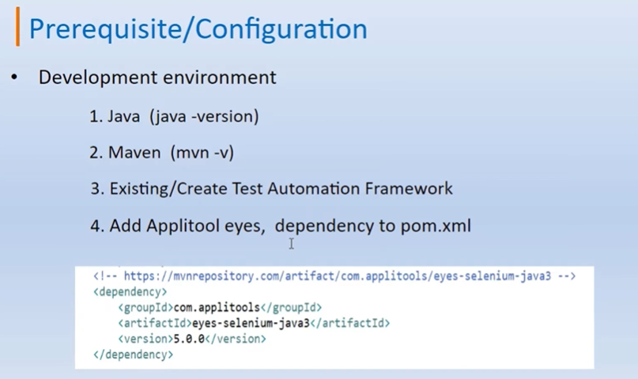

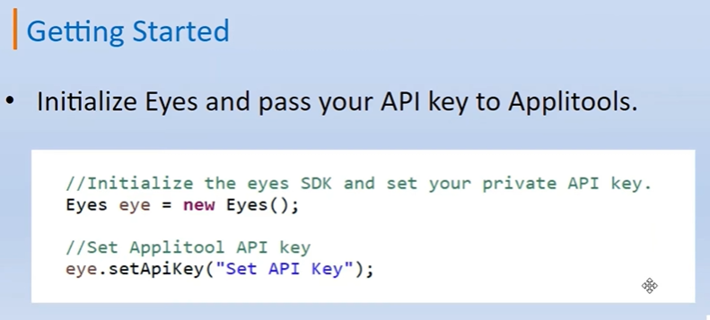

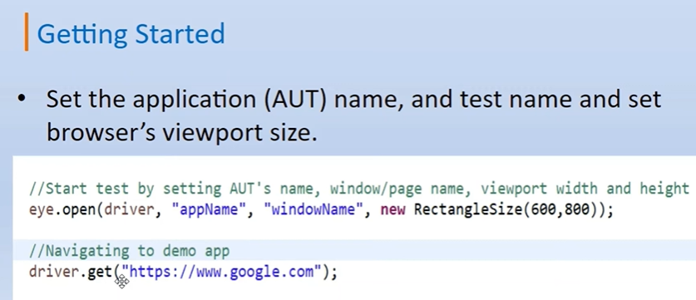

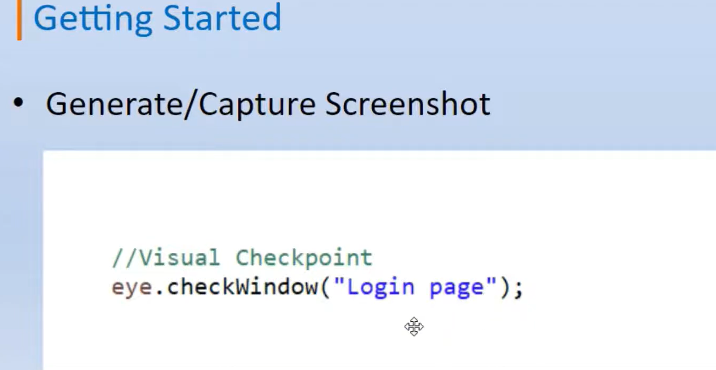

**Match Level :**

**EXACT:** Not Used generally

**STRICT:** Selected by Default

**Testing The tool**

**Running the test case for First Time**

**Running the test case for second time**

**Changing the URL and testing the Visual changes**

**public class AndroidVisualTest {**

**private Eyes eyes;**

**private AndroidDriver driver;**

**@Before**

**public void setup(){**

**eyes = new Eyes();**

**eyes.setApiKey(System.getenv("APPLITOOLS_API_KEY"));**

**DesiredCapabilities caps = new DesiredCapabilities();**

**caps.setCapability("platformName", "Android");**

**caps.setCapability("app", "/path/to/app.apk");**

**driver = new AndroidDriver(new URL("http://localhost:4723/wd/hub"), caps);**

**eyes.open(driver, "My Android App", "Visual Test Run");**

**}**

**@Test**

**public void testLoginScreen(){**

**eyes.checkWindow("Initial Login Screen");**

**}**

**@After**

**public void teardown(){**

**eyes.close();**

**driver.quit();**

**}**

**}**